Pokhara University

Level: Bachelor | Semester – Spring | Year : 2005
Programme: BE |  | Full Marks: 100
Course: Signal System and Processing |  | Time : 3hrs.

Candidates are required to give their answers in their own words as far as practicable.
The figures in the margin indicate full marks.

Attempt all the questions.

 | - What are basic elements of Digital Signal Processing? What are the advantages of digital signal processing over analog signal processing?  - Find out Z-transform of x[n] = a^{n} sin (ω₀n) u [n]. Also find ROC. | 7  8
 | - If x[n] and h[n] are the input and impulse response of the discrete LTI system. Find out the expression for output of the LTI system.  - What is the advantage of the adjustable window over the fixed window in FIR filter design? What is the price paid off for that? | 7  8
 | - What is linear phase FIR filter? Discuss about FIR filter design by frequency sampling method.  - Discuss the IIR filter design by impulse invariance method. | 7  8
 | - Convert the analog filter with a system function  H_{a} (s) = 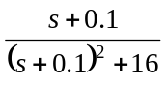  into a digital IIR filter by means of the bilinear transformation. The digital filter is to have a resonant frequency of ω_{r} = 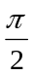.  - State and prove circular frequency shift property of DFT. | 10  5
 | - Determine the FIR filter with specified by lattice parameters k₁ = , k₂ = 0.6, k₃ = -0.7 and k₄ = .  - Suppose that we have a digital filter having a pole at a = . The filter is implemented with fixed point arithmetic based on 4-bit for the magnitude plus a sign-bit (total of 5-bits). Quantization that takes place after multiplication is assumed to round the resulting product upward. If input signal is x[n] =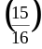 (n). Find out output of the filter up to n = 5 (assuming system is initially relaxed.  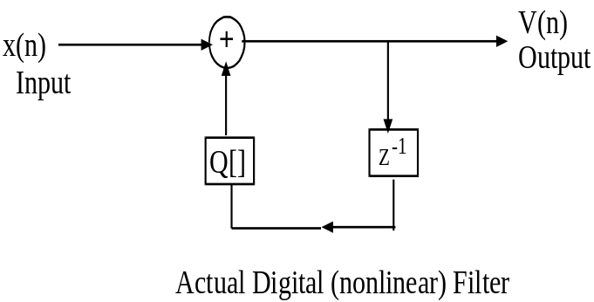 | 7  8
 | a) Compute the linear convolution of two sequences x₁(n) and x₂(n). Given;  x₁(n) = {1, 2, 3, 4, 5} and x₂(n) = {1, 1, 2, 2}.  b) What do you mean by time invariant system? How can you differentiate a time invariant system from a time variant system? Check whether the following system is time invariant or variant.  y(n) = n x(n) | 7  8
 | Write short notes on  - Butterworth low-pass filter  - Frequency response of discrete LTI system | 2x5

